Information Sheet XX / 2014
Science and Conservation Division

Effective control of Geraldton carnation weed (Euphorbia terracina) facilitates recovery of invaded plant communities

by Kate Brown, Julia Cullity and Grazyna Paczkowska, DPaW Swan Region, 08 94420321 kate.brown@dec.wa.gov.au

Background
Geraldton carnation weed (Euphorbia terracina) is an invasive weed that impacts native plant communities across southern mainland Australia. A short lived herbaceous perennial, Geraldton carnation weed is native to southern Europe, western Asia and north Africa, where it occurs on sand dunes and shallow calcareous soils. It can be found invading remnant natural areas across south-west Australia including many of conservation significance. Particular habitats at risk include offshore islands and plant communities on calcareous soils. Where Geraldton carnation weed invades it forms dense monocultures and has significant negative impact on native species abundance and diversity. Yet there is little published information on effective control techniques for Geraldton carnation weed or on the recovery and restoration of invaded plant communities once it has been removed.
We aimed to develop appropriate control techniques for Geraldton carnation weed while monitoring the associated response and recovery of the flora of Banksia/eucalypt woodlands, sedgelands in Holocene dune swales, and coastal shrublands, on the Swan Coastal Plain of south-west Western Australia.
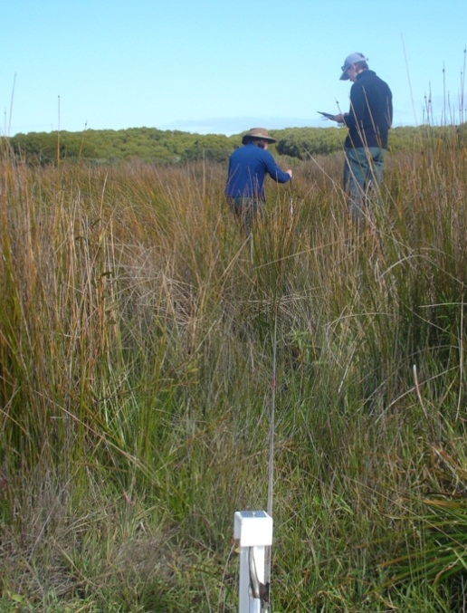
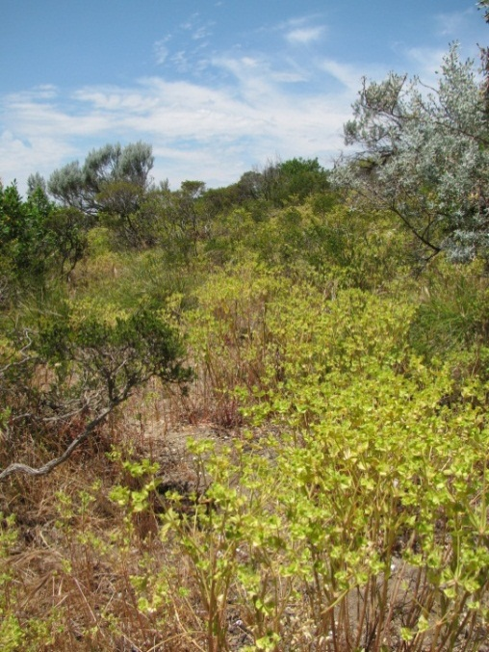

From left. Geraldton carnation weed forms dense monocultures where it invades coastal shrublands (photo 1). It is a short lived herbaceous perennial that can resprout from persistent roots following fire (centre). Measuring response and recovery of sedgelands in Holocene dune swales (photo 2).

Findings
- In sedgelands of the Holocene dune swales and in coastal shrublands Logran® (750g/kg triasulfuron) at 12.5 g/100 L plus the penetrant Pulse® (2 mL/L) applied in July provided very effective control, reducing Geraldton carnation weed populations significantly in the first two years. The treatment resulted in little damage to native flora. A fire in the sedgelands two years after the control program commenced resulted in no seed germination or recruitment of Geraldton carnation weed. In both sedgelands and coastal shrublands a significant difference in species abundance between years was attributed mostly to a decrease in the cover of Geraldton carnation weed but also an increase in cover of several species of native flora.
- In Banksia woodlands the herbicide Brush-Off® (600g/kg metsulfuron-methyl) at 0.2 g/10L plus the penetrant Pulse® applied in July combined with hand removal of adult plants in November took five years of repeated application to gain effective control. The soil disturbance caused by physical removal of adult plants not killed by Brush-off® appeared to facilitate continued germination of soil stored seed of Geraldton carnation weed. In addition the initial application of Brush-off® resulted in off target damage to native flora.
- In all three plant communities the removal of Geraldton carnation weed resulted in an increase in the cover of non-native annual herbs and grasses.
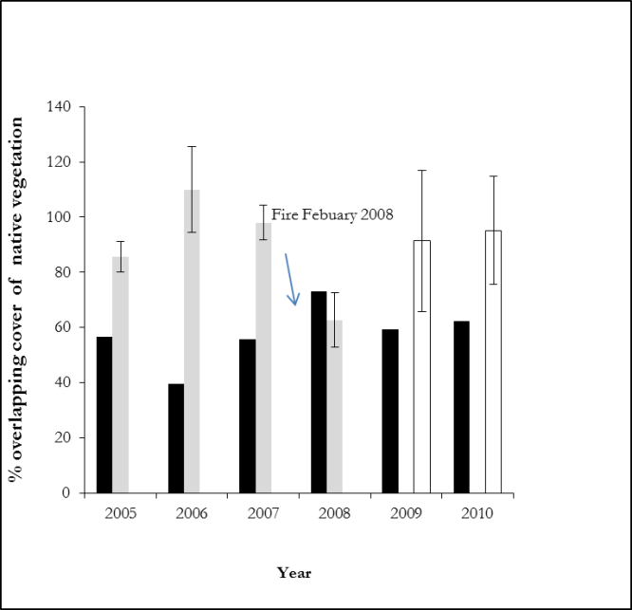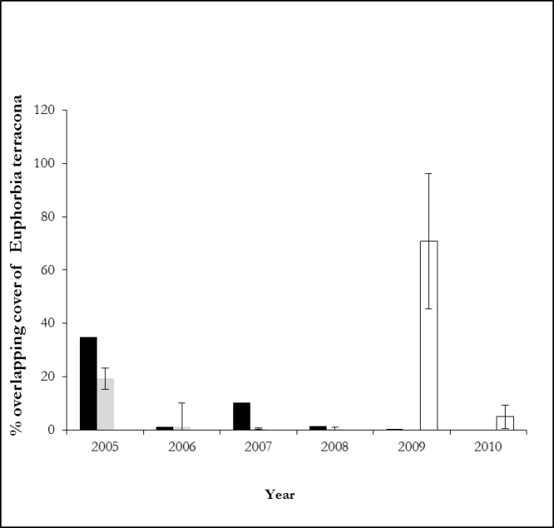

a) b)
Figure 2a). Change in total cover of native vegetation and b) Geraldton carnation weed across sites over five years before and following ( treatment with Brush-off (Banksia woodland, Paganoni Swamp, black bars), and Logran (Holocene dune swales, Point Becher, grey bars, and coastal shrublands, Burns Beach, white bars). Paganoni data was estimated from midpoint Braun-Blanquet cover values, Point Becher and Burns Beach data was measured using point intercepts.At Paganoni the trial commenced in 2005 (before treatment) and continued 2006-2010 (flollowing treatment). Point Becher commenced in 2005 (before treatment) and continued 2006-2008 (following treatment). Burns Beach commenced in 2009 (before treatment) and continued in 2010 (following treatment).

Management Implications
- The herbicide Logran® can reduce populations of Geraldton carnation weed significantly in the first years of a control program with little off target damage to co-occurring native species. In the coastal sedgelands and shrublands of south-west Australia control of Geraldton carnation weed with Logran® can facilitate recovery of these native plant communities over time. Further trials are required in Banksia woodland to investigate off target damage of Logran® to associated native flora.
- Application of Brush-off® on juvenile plants and physical removal of adult plants are not the recommended control options for Geraldton carnation weed invading native plant communities.
- Any restoration strategy for native vegetation invaded by Geraldton carnation weed should consider the implications of increased cover of non-native annual grasses and investigate methods to address possible causes.

Further information: Brown K, Cullity J, Paczkowska G. (in press) Recovery of native plant communities following control of Terracina Spurge (Euphorbia terracina): Three case studies from south-west Western Australia. Ecological Restoration

Produced and published by the Science Division, Department of Parks and Wildlife, Western Australia,
Locked Bag 104, Bentley Delivery Centre, WA 6983

Produced and published by the Science Division, Department of Parks and Wildlife, Western Australia,
Locked Bag 104, Bentley Delivery Centre, WA 6983

